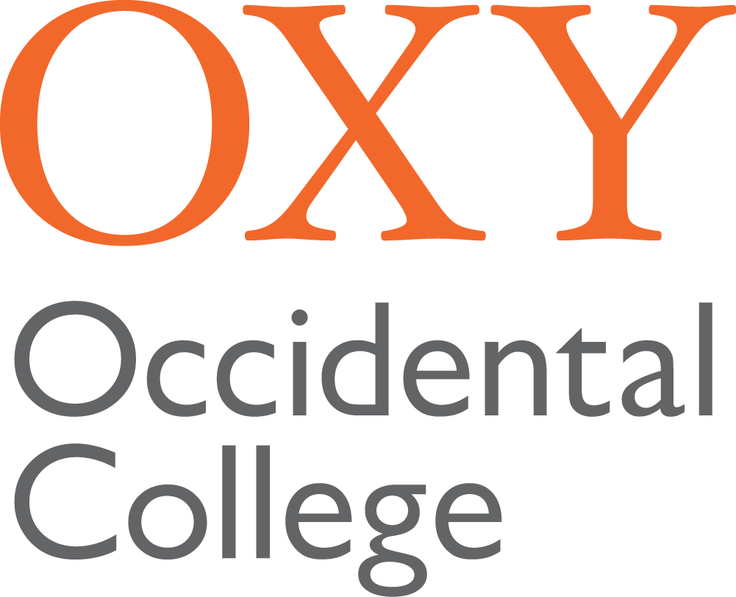

TYPE JOB TITLE HERE
Type Office or Department Name Here

POSITION SUMMARY

Please use this space to provide two or three sentences to describe the position and, where appropriate, the project.

SUMMARY OF DUTIES, RESPONSIBILITIES AND GOALS

In most cases, it is difficult, if not impossible, to list every duty that someone will perform. In this area, please list the major responsibilities of the position. Typically, positions will have at least three responsibilities and no more than twelve responsibilities. Use as many lines as you need.

QUALIFICATIONS
Qualifications should be listed as either:
- Minimum Qualifications - any qualification (knowledge, skill or ability required to do the job) listed in this section will be considered absolutely necessary. For future searches, if a candidate does not have any particular minimum qualification, they will be considered to be not qualified for the position and not considered further.
- Preferred Qualifications - preferred qualifications are those that may be desirable (or highly desirable) but not absolutely essential to perform the position. If a candidate in a future search does not have a preferred qualification, they can still be considered as a qualified candidate.

APPLICATION INSTRUCTIONS

Please submit a resume and cover letter explaining how your qualifications meet the requirements of the position to resumes@oxy.edu.

ADDITIONAL INFORMATION

Occidental is an Equal Opportunity Employer and does not unlawfully discriminate against employees or applicants on the basis of race, color, religion, sex, sexual orientation, gender identity, gender expression, pregnancy, breastfeeding or related medical condition, national origin, ancestry, citizenship, age, marital status, physical disability, mental disability, medical condition, genetic characteristic or information, military and veteran status, or any other characteristic protected by state or federal law. Occidental is strongly committed to increasing the diversity of the campus community and the curriculum, and to fostering an inclusive, equitable, and just environment within which students, staff, administrators, and faculty thrive. Candidates who can contribute to this goal through their work are encouraged to identify their strengths and experiences in this area. Individuals advancing the College’s strategic equity and justice goals and those from groups that are underrepresented in the field are particularly encouraged to apply.
Salary is commensurate with experience and qualifications. A comprehensive benefits package is available that includes: excellent health, dental, life, and retirement benefits; tuition benefits for the employee, spouse, domestic partner, and dependents; additional extras including use of gym facilities and the College Library. For a detailed description of benefits, please visit https://www.oxy.edu/offices-services/human-resources/benefits-information.
All qualified applicants will be considered for employment, including those with criminal histories, in a manner consistent with the requirements of applicable state and local laws, including the City of Los Angeles’ Fair Chance Initiative for Hiring Ordinance.
Occidental College is committed to working with and providing reasonable accommodations to applicants with qualifying disabilities. If you need a reasonable accommodation because of a disability for any part of the application or employment process, please contact Human Resources (hr@oxy.edu).
As a condition of hire for a staff position and for appointment to a faculty position, Occidental College requires that all candidates who have received a conditional offer of employment complete an application form (if they have not already done so) and consent to a background check. Satisfactory completion of a background check, along with pre-employment verifications and references are required as a condition of employment, but only as permitted by federal, state, and local law, including the City of Los Angeles Fair Chance Initiative for Hiring Ordinance.

